(Nagios server)

yum -y install httpd php gcc glibc glibc-common wget perl gd gd-devel unzip zip

yum install epel-release

useradd nagios

groupadd nagcmd

usermod -a -G nagcmd nagios

usermod -a -G nagcmd apache

cd /

mkdir nagios

wget https://assets.nagios.com/downloads/nagioscore/releases/nagios-4.3.4.tar.gz

tar -zxvf nagios-4.3.4.tar.gz

cd nagios-4.3.4/

./configure --with-nagios-group=nagios --with-command-group=nagcmd

make all

make install

make install-init

make install-config

make install-commandmode

make install-webconf

make install-exfoliation

htpasswd -c /usr/local/nagios/etc/htpasswd.users nagiosadmin

systemctl restart httpd

systemctl enable httpd

cd /nagios

wget <https://nagios-plugins.org/download/nagios-plugins-2.2.1.tar.gz>

tar -zxvf nagios-plugins-2.2.1.tar.gz

cd nagios-plugins-2.2.1

./configure --with-nagios-user=nagios --with-nagios-group=nagios

make

make install

/usr/local/nagios/bin/nagios -v /usr/local/nagios/etc/nagios.cfg

(check Nagios configuration files)

chkconfig nagios on

service nagios start/restart

http://<ipaddressofserver/nagios/

yum -y install nagios-plugins-nrpe

vi /usr/local/nagios/etc/nagios.cfg

cfg_dir=/usr/local/nagios/etc/servers

Object Definitions

<https://assets.nagios.com/downloads/nagioscore/docs/nagioscore/3/en/objectdefinitions.html>

vi /usr/local/nagios/etc/servers/test3.cfg

define host{

host_name test3

alias test3

address 192.168.1.172

check_period 24x7

notification_interval 30 (in minutes)

notification_period 24x7

max_check_attempts 3

check_command check-host-alive

}

define service {

use local-service

host_name test3

service_description SSH

check_command check_ssh!-p 22

}

NRPE siz servis tanımı

define service{

host_name test4

service_description HTTP

check_command check_http OR check_http!-S

max_check_attempts 3

check_interval 5

retry_interval 1

check_period 24x7

notification_interval 60

notification_period 24x7

}

Host tanımı Açıklamaları

Alias: human-readable name for the host; it appears in the web interface.

max_check_attempts: defines the number of times Nagios Core should try to repeat the check if checks fail. If, we defined a value of 3, meaning that Nagios Core will try two more times to PING the target host after first finding it down.

notification_interval: This defines how regularly the host should repeat its notifications if it is having problems. Here, we've used a value of 60, which corresponds to 60 minutes or one hour.

Servis tanımı açıklamaları(nrpe’siz)

If Nagios Core can't get a response to its check, then it will flag the state of the service as CRITICAL,

will try again up to two more times before sending a notification.

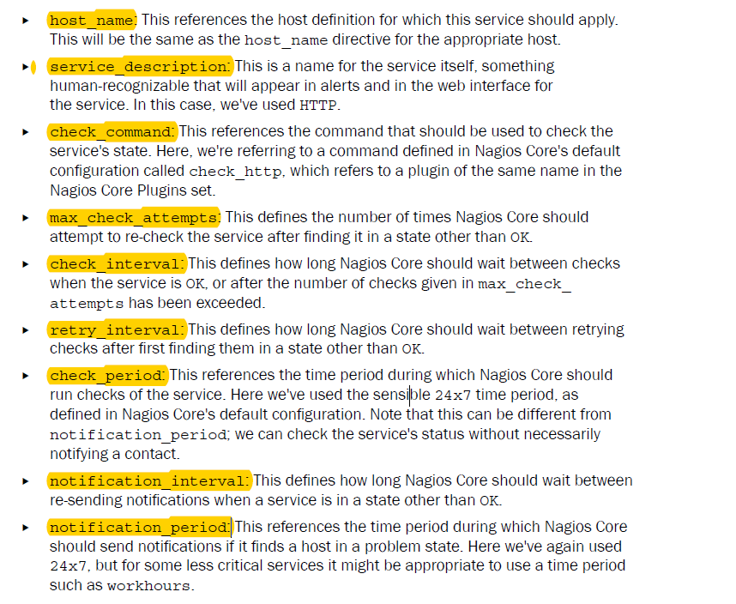

Creating new e-mail contact

vi /usr/local/nagios/etc/objects/contacts.cfg

define contact {

contact_name test4admin

alias Administrator of sparta.naginet

email yaydog@gmail.com

host_notification_commands notify-host-by-email

host_notification_options d,u,r

host_notification_period 24x7

service_notification_commands notify-service-by-email

service_notification_options w,u,c,r

service_notification_period 24x7

host_notifications_enabled 1

}

Host ve servis tanımlarına vi /usr/local/nagios/etc/servers/test4.cfg

>>>>>>> contacts test4admin

satırı eklenir

Contact name açıklamaları

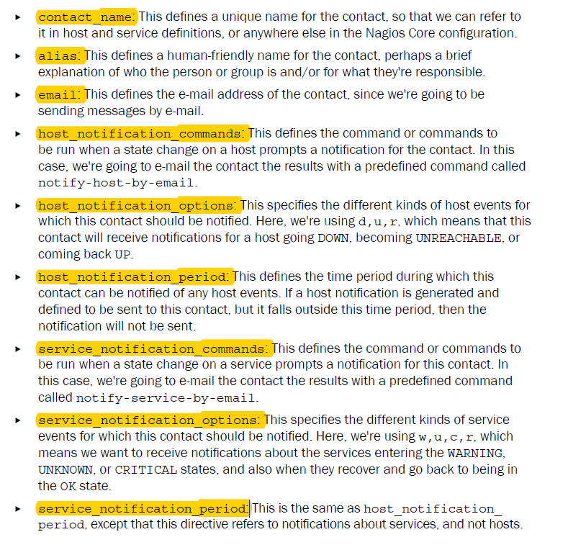

Creating Host Group

vi /usr/local/nagios/etc/objects/hostgroups.cfg

define hostgroup {

hostgroup_name Linux servers

alias Production

members test3,test4

}

vi /usr/local/nagios/etc/nagios.cfg

cfg_file=/usr/local/nagios/etc/objects/hostgroups.cfg

Creating new time period

vi /usr/local/nagios/etc/objects/timeperiods.cfg

define timeperiod {

timeperiod_name weekdays

alias Weekdays

monday 00:00-24:00

tuesday 00:00-24:00

wednesday 00:00-24:00

thursday 00:00-24:00

friday 00:00-24:00

}

define timeperiod {

timeperiod_name weekends

alias Weekends

saturday 00:00-24:00

sunday 00:00-24:00

}

Host ve servis konfigurasyonu içerisinde

notification_period weekends yazılır

**NOTIFICATION OPTIONS**

d: down

r: recovery

w: warning

u: unreachable

Örnek: host definition içerisine

**notification_options**

**notifications_enabled**

parametreleri eklenir

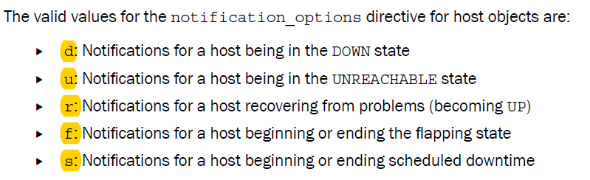

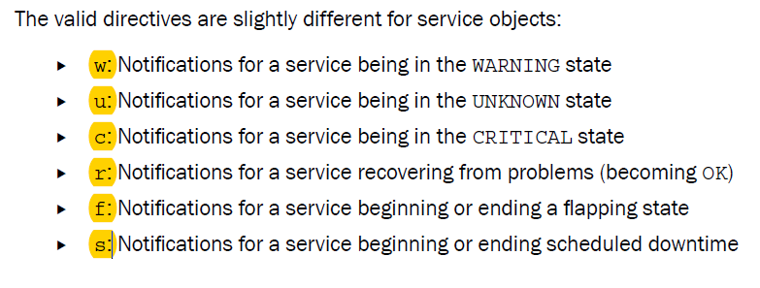

vi /usr/local/nagios/etc/objects/commands.cfg

# .check_nrpe. command definition

define command{

command_name check_nrpe

command_line **/usr/lib64/nagios/plugins/check_nrpe** -H $HOSTADDRESS$ -t 30 -c $ARG1$

}

**BELİRLİ BİR TCP PORTU KONTROL ETMEK**

define service{

host_name test4

service_description LDAP

check_command check_tcp!389

max_check_attempts 3

check_interval 5

retry_interval 1

check_period 24x7

notification_interval 60

notification_period 24x7

contacts systemadmin

}

**MONITORING MAIL SERVICES**

Servis tanımı altına:

check_command check_(s)smtp

check_command check_(s)pop

check_command check_(s)imap

(s) for secure connection check

**CONNECTION’U TEST ETMEK**

check_command check_ping!100,20%!200,40%

rtt 100 den fazlaysa warning 200 den fazlaysa critical

packet loss %20 den fazlaysa warning %40dan çoksa critical

PING OK - Packet loss = 0%, RTA = 0.71 ms

**DISK SPACE’I MONITOR ETMEK**

check_local_disk!10%!5%!/wwwroot

%10’dan az yer varsa critical

%5 den az yer varsa warning

/usr/local/nagios/libexec/check_disk -w 10% -c 5% -p /wwwroot

**BELİRLİ BİR WEB SAYFASINI MONİTOR ETMEK**

vi /usr/local/nagios/etc/objects/commands.cfg

define command {

command_name check_http_page

command_line $USER1$/check_http -I $HOSTADDRESS$ -u $ARG1$

}

Servis tanımı içerisine

check_command check_http_page!/about.php

**BELİRLİ BİR WEB SITESINI MONİTOR ETMEK**

check_command check_http_host!www.naginet

<http://www.naginet/> i control eder

**VERITABANINI KONTROL ETMEK (MYSQL)**

(veritabanı sunucusu üzerinde)

create user 'nagios'@'nagioserverip’ identified by 'lapland23';

grant all privileges on *.* to 'nagios'@'nagiosserverip';

FLUSH PRIVILEGES;

(Nagios server üzerinde)

yum install mysql

cd /nagios/ nagios-plugins-2.2.1

./configure --with-nagios-user=nagios --with-nagios-group=nagios

make

make install

bu işlemlerden sonra /usr/local/nagios/libexec altnda check_mysql ve check_mysql_query oluşur

usr/local/nagios/libexec/check_mysql -H “mysql_serverip” -u nagios -p lapland23

(plugin in çalıştığı test edilir)

vi /usr/local/nagios/etc/objects/commands.cfg

define command {

command_name check_mysql

command_line $USER1$/check_mysql -H $HOSTADDRESS$ -u $ARG1$ -p $ARG2$

}

define command {

command_name check_mysql_query

command_line $USER1$/check_mysql_query -H $HOSTADDRESS$ -u $ARG1$ -p $ARG2$ -d $ARG3$ -q $ARG4$

}

Servis tanımına

check_command check_mysql!nagios!lapland23

check_command check_mysql_query!nagios!lapland23!mysql!"SELECT COUNT(1) FROM user"

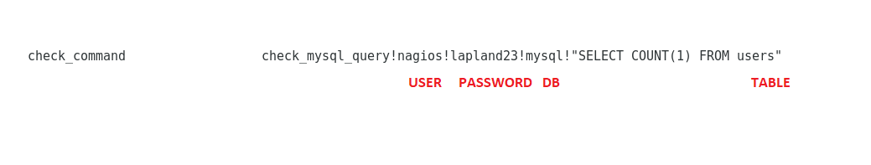

satırı eklenir

**EXAMPLE PLUGINS**

cd /usr/local/nagios/libexec

wget 'http://exchange.nagios.org/components/com_mtree/attachment.php?link_id=307&cf_id=29' -O check_rsync

chown nagios.nagios check_rsync

chmod 0770 check_rsync

./check_rsync (to findout definition of the plugin)

vi /usr/local/nagios/etc/objects/commands.cfg

define command {

command_name check_rsync

command_line $USER1$/check_rsync -H $HOSTADDRESS$

}

Service tanımına check_command check_rsync

Satırını ekle

**FLAP DETECTİON**

Host ve servis tanımlarına

high_flap_threshold 45.0

low_flap_threshold 20.0

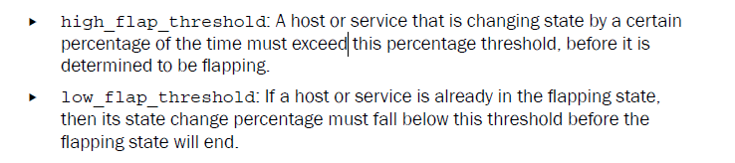

**NRPE DAEMON**

(remote host) (NRPE ile izlenecek ise)

yum install epel-release

yum install -y nrpe nagios-plugins-all openssl

vi /etc/nagios/nrpe.cfg (izlenilecek sunucu üzerinde)

allowed_hosts=127.0.0.1, **192.168.1.170**

systemctl start nrpe

chkconfig nrpe on

(Nagios server üzerinde)

/usr/lib64/nagios/plugins altında check_nrp plugin’i oluşur

vi /usr/local/nagios/etc/objects/commands.cfg

define command{

command_name check_nrpe

command_line /usr/lib64/nagios/plugins/check_nrpe -H $HOSTADDRESS$ -t 30 -c $ARG1$

}

Nagios server üzerinden client’ta nrpe’nin çalışmasının kontrolü

/usr/lib64/nagios/plugins/check_nrpe -H “clientIP”

Nagios server üzerinde nrpe komutlarının çalıştırılması:

/usr/lib64/nagios/plugins/check_nrpe -H “clientIP” -c “komut ismi”

vi /etc/nagios/nrpe.cfg >alert limitleri

vi /usr/lib64/nagios/plugins >> ve nrpe pluginleri buradadır (örnek plugin: check_swap)

örnek: **command[check_swap]=/usr/local/nagios/libexec/check_swap -w 10% -c 5%**

Nagios server üzerinde Servis tanımına yazılması

define service{

use local-service

host_name test3

service_description Current Users

check_command check_nrpe!check_users

}

define service{

use local-service

host_name test3

service_description Total Processes

check_command check_nrpe!check_total_procs

}

define service{

use local-service

host_name test3

service_description Current Load

check_command check_nrpe!check_load

}

All Configuration Files

/usr/local/nagios/etc/nagios.cfg (main Nagios config file)

Explanation: <https://assets.nagios.com/downloads/nagioscore/docs/nagioscore/3/en/configmain.html>

/usr/local/nagios/etc/objects/contacts.cfg (enter e-mail to receive alerts)

/etc/httpd/conf.d/nagios.conf (nagios’un web arayüz ayarları)

/usr/local/nagios/bin/nagios -v /usr/local/nagios/etc/nagios.cfg (configuration file check)

/usr/local/nagios/bin/nagios -s /usr/local/nagios/etc/nagios.cfg (performance check)

/usr/local/nagios/var/nagios.log (log file)

/usr/local/nagios/etc/objects/commands.cfg

/usr/local/nagios/etc/objects/localhost.cfg (Nagios Server’ın host bilgileri ve izlenen servisler)

/usr/local/nagios/libexec (plugins)

vi /usr/local/nagios/etc/servers/test3.cfg (host configuration)

Acknowledgement of status

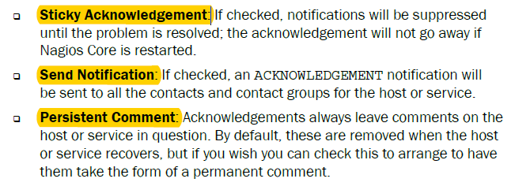

Network Map’a Logo eklemek

vi /usr/local/nagios/share/images/logos (network mapdeki semboller)

Host definition tanımına

icon_image rack-server.gif

icon_image_alt Rack Server

statusmap_image rack-server.gd2

satırları eklenir

Host Dependency (VM’leri monitor etmek için kullanılabilir)

vi /usr/local/nagios/etc/objects/dependencies.cfg

define hostdependency {

host_name test3

dependent_host_name test4

execution_failure_criteria n

notification_failure_criteria d,u

}

Test3, test4 e bağlanmış olur

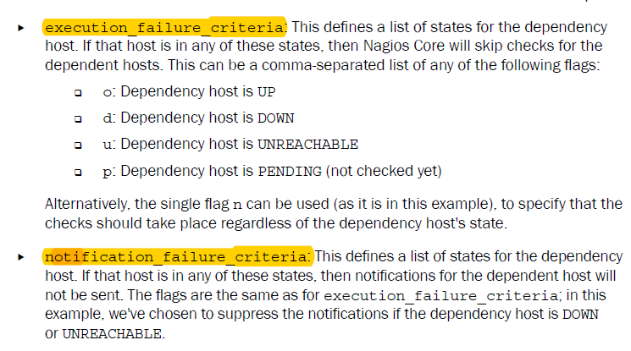

Service Depedency

vi /usr/local/nagios/etc/objects/dependencies.cfg

define servicedependency {

host_name test3

service_description SSH

dependent_host_name test3

dependent_service_description PING

execution_failure_criteria c

notification_failure_criteria c

}

SSH’I ping’e bağlamak

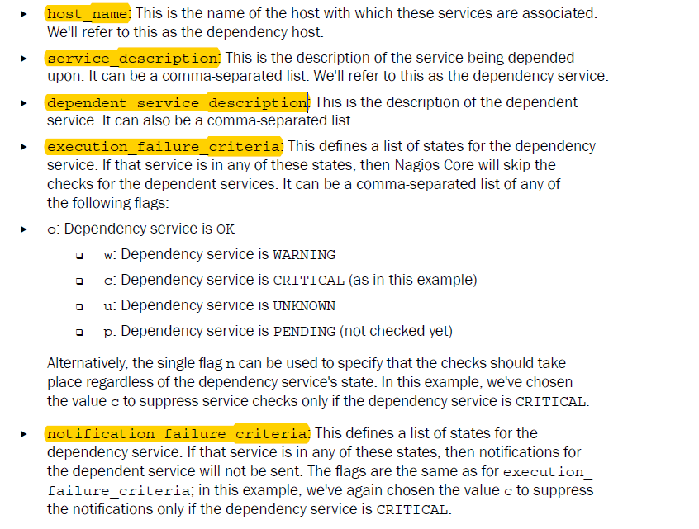

MONITORING NODES IN CLUSTER

Test3, test4, test5 ile bir cluster monitor yapılması

vi /usr/local/nagios/etc/objects/commands.cfg

define command {

command_name check_dummy

command_line $USER1$/check_dummy $ARG1$ $ARG2$

}

define command {

command_name check_host_cluster

command_line $USER1$/check_cluster -h -d $ARG1$ -w $ARG2$ -c $ARG3$

}

vi /usr/local/nagios/etc/servers/dummy.cfg

define host {

host_name clustermonitor

alias clustermonitor

address 127.0.0.1

max_check_attempts 1

check_command check_dummy!0!"Dummy host only"

}

define service {

use generic-service

host_name clustermonitor

service_description CLUSTER

check_command check_host_cluster!$HOSTSTATEID:test3$,$HOSTSTATEID:test4$,$HOSTSTATEID:test5$!@1:!@2:

notification_options c,w,r

}

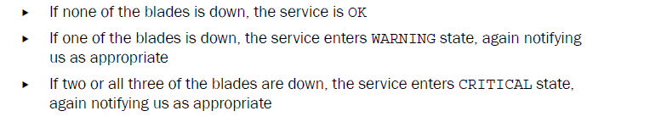

Check status of the cluster manually

/usr/local/nagios/libexec/check_cluster -h -d 0,0,1 -w @1: -c @2:

MONITORING SERVICES IN CLUSTER

Cluster üzerinden http’yi izler

vi /usr/local/nagios/etc/objects/commands.cfg

define command {

command_name check_service_cluster

command_line $USER1$/check_cluster -s -d $ARG1$ -w $ARG2$ -c $ARG3$

}

define service {

use generic-service

host_name clustermonitor

service_description CLUSTER_HTTP

check_command check_service_cluster!$SERVICESTATEID:test3:HTTP$,$SERVICESTATEID:test4:HTTP$,$SERVICESTATEID:test5:HTTP$,!@1:!@2:!@3:

}

**ADDING READ ONLY USER TO NAGIOS WEB PANEL**

vi /usr/local/nagios/etc/cgi.cfg

use_authentication=1

default_user_name=yaydog

vi /etc/httpd/conf.d/nagios.conf

AuthName "Nagios Access"

AuthType Basic

AuthUserFile /usr/local/nagios/etc/htpasswd.users

Require valid-user

htpasswd /usr/local/nagios/etc/htpasswd.users yaydog

vi /usr/local/nagios/etc/cgi.cfg

authorized_for_all_servicess=nagiosadmin,yaydog

authorized_for_all_hosts=nagiosadmin,yaydog

authorized_for_read_only=yaydog

user rights

